Chapter 8, Problem 34.

Calculate i(t) for t > 0 in the circuit in Fig. 8.82.

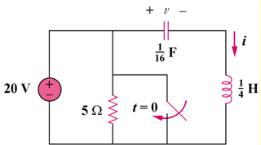
50u(–t) V

5 Ω

Figure 8.82
For Prob. 8.34.

